Meeting Notes from GCCG “Virtual” Quarterly Meeting
16th June 2021

Summer is coming.

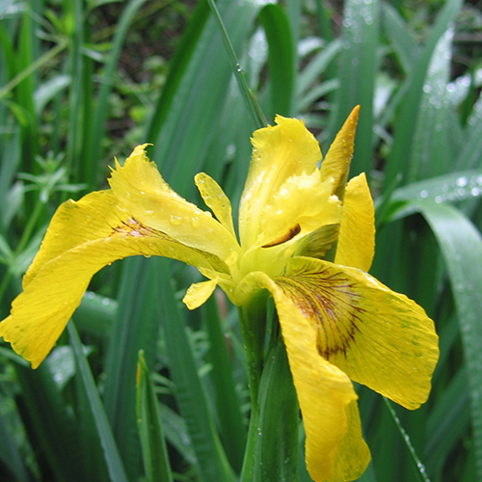
Yellow Iris

Chairman’s welcome

Once more we are forced to only meet “virtually” due to ongoing Covid restrictions, but as ever we have remained active in our mission to look after The Carrs and all its wild residents and plants.
The various reports below once again confirm what has been happening and also maintain the formal duties of our constitution.
I hope you all enjoy these latest reports and we welcome any feedback and comments.

Attendance
Everyone, at home.

Minutes from last meeting
Sent out to you all.

Secretary/Membership Report; Pete Phethean

For virtual quarterly meeting June 2021
Currently we have 134 members.
53 of them have already renewed their subscription during 2021 (January to
mid-June) and therefore their subscription fee will not be due again until
next year.
59 memberships are due to be renewed during mid-March to end December
2021 and are therefore in subscription.
22 existing members are late with their subscription. Again, this is possibly
because of the ongoing restrictions on social contact. Gentle reminders and
standing order forms will be emailed out to help things along. Please consider
subscribing via standing order if you do not do so already because this method
is the most convenient for members and membership records.
37 of the memberships are single memberships with a £5 subscription fee.
97 of the memberships are family memberships with a £7.50 subscription fee.
This total of 134 members is eight more than the March 2021 tally. The
increase represents both new members and former members who re-
subscribed. A warm welcome goes to them.
On Easter Saturday we held a ‘fundraising drive’ in the car park of The Carrs which produces over £100 in donations from the day’s visitors and a handful of new members. Thanks go to all the members who helped by welcoming the visitors and receiving the donations.

Comment;
Thanks again to Pete for keeping the records up to date and for his ongoing prompt response in enrolling the many new members wishing to join our Group in recent months.

Treasurer’s report; Michelle Inwood.

GCCG Treasurer’s Report for March 2021 Virtual Meeting
(5 March – 4 June 2021)

5 Mar 2021 balance £2936.87
4 June 2021 balance £4672.37

Incomings £
Easter event 116.00
Memberships/donations 152.50
Plus donations of £25 or more:
- Gatley United Reform Church 250
- Delgado-Hernandez / Tinkler 100
- Snape 25
- Police crime community fund 592
- Cheadle & Gatley Round Table 500
Total income 1735.50

Outgoings £
Total outgoings (as shown on bank statements) 0

*Note, additional cash income from memberships and donations with monies going directly to Carrs site maintenance:
- Low emission oil for the strimmer 14.92
- Replacement petrol fuel cap 11.93
Total outgoings 26.85

Summary: A healthy quarter with minimal outgoings and sizeable donations. Thank you!

As we currently have no other sources of income, we rely on the public for donations and for membership. If you would like to set up an online automatic payment, regular or one-off, the account details are as follows:
Gatley Carrs Conservation Group
Sort code: 01-01-75
Account no: 19082894
Thank you for your support.
Michelle Inwood
GCCG Treasurer
13th June 2021

Comment;
Thanks again to Michelle for her very efficient record keeping.
Latest finance news;
As reported above we are very grateful for the donations received in the last quarter, most notably from Delgado and Tinkler, Elm Road Church, the Police Crime Community Fund and most recently from Cheadle and Gatley Round Table.
These donations ae invaluable in allowing us to maintain and improve The Carrs.

Bird Report ; Chris Neil

GATLEY CARRS BIRD REPORT MAY 2021
Nobody could have predicted just how severe the weather would be for the most of the month of May. Constant heavy rain with strong winds and near freezing temperatures kept most of us indoors. Definitely not good for bird watching. Towards the end of the month finally it became sunny and we welcomed a quite warm period and it was great to be able to spend more time at the Reserve.
Plenty of action on the Pond all month. A Male Mandarin, affectionately christened “Pip”, had originally been seen 30th April. He was obviously used to people and came over daily for food throughout the month. It was thought he had relocated from Abney Hall. On the 25th a Female Mandarin joined him but did not stay long. A second Male arrived 30th May.
A brood of 5 Canada goose young was seen 15th May and a second brood of 8 on 20th May.
The first brood of 4 Moorhen chicks appeared 30th May. The Grey Heron was often seen, usually in the channel opposite the bird screen. The maximum number of Domestic Ducks seen was 5 including the long-term resident Muscovy known of as Gary.
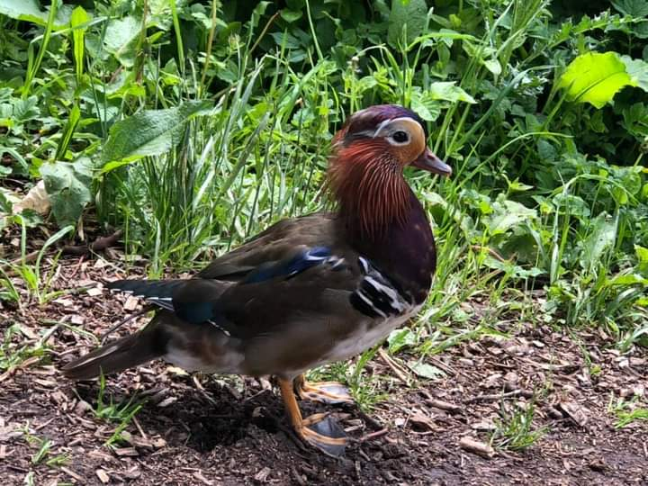
Male Mandarin
My final visit of the month was 31st. Although it was a bank holiday and, also glorious weather, I expected it to be busy when I arrived at 9-15 but it wasn’t at all with just a few dog walkers about. The Reserve was alive with birds singing and it was a real joy to be there. I heard 4, possibly 5, Blackcap, not so showy now as they were in deep cover.
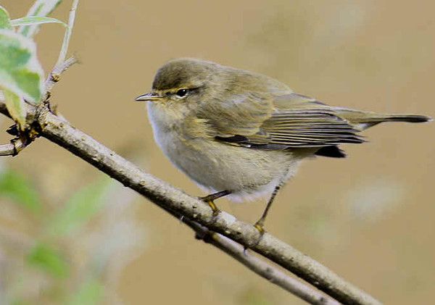
Chiffchaff
Just 2 Chiffchaff still in song, it is often said that this species sometimes stops singing when they are paired up. So it is possible we have 2 Males who have not yet found a Female.
A pair of Bullfinch were by the Pond collecting food so obviously they have got young nearby. Plenty of Goldfinch in their usual place. It is hard not to see them once you hear their tinkling song. Song Thrush, Blackbird, Wren, Dunnock, Robin, Chaffinch and Greenfinch singing too.
It was a sheer delight to spend 3 hours on a beautiful day. Such a treat to see all the birds, glorious flowers and plenty of Butterflies.
Comment;
Thanks go yet again to Chris for her keen observations and reporting.
CARRS WILDLIFE REPORT APRIL-JUNE 2021
Spring this year has been late and cold. Monthly displays on the wildlife information board on the upper field suggest that there has been a delay of several weeks resulting from a cold dry April and a cold wet May. Garden nest boxes have shown failures of some Blue Tits to fledge. This may have happened on the Carrs.
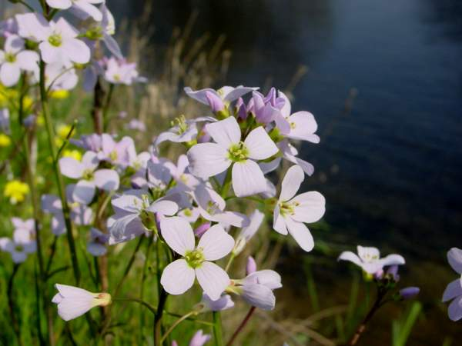
Cuckoo flowers
There were few flowers on the wild flower meadow, lone Cuckoo flowers, Cowslips, Warty Cabbage and one Fritillary, no orchids. However, clearing and hand planting of seeds and plugs of wild flowers seem to be taking well in several plots thanks to Chris Mullins and his team.
In other habitats Wild Garlic, Bluebells, Kingcups, Cow Parsley and Three-cornered Leeks all flourished, but late. Butterflies produced up to 11 species shown by our wildlife photographers on our Facebook page.
Bird life on the ponds was normal but a couple of weeks late. Moorhens on a nest on the dipping pond hatched 4 chicks, but few survived. Canada Geese produced at least 8 goslings from two pairs of parents, but they too were not seen for long. A lone male Mandarin duck, later joined by his mate, appeared at the pond feeding station in May. Kingfishers were seen on the pond and several Herons, including juveniles.

Trees have been flowering, yellow Norway Maple and Sycamore, white Bird Cherry by the seat and beside the dipping pond.
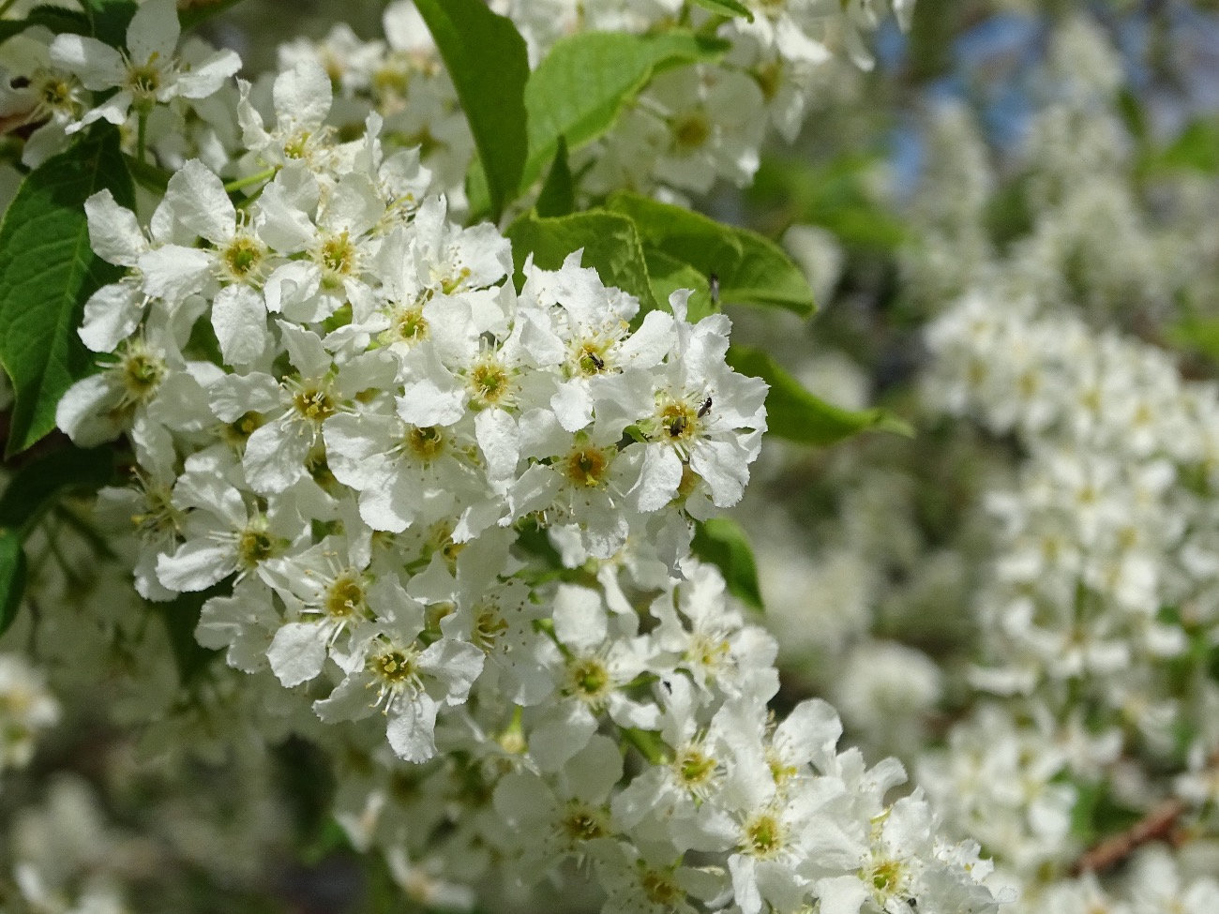
White Bird Cherry
There was a good display of blossom in the orchard and of May (Hawthorn) widely across the Carrs. Sadly two mature Ash trees, near ‘Bert’ the Field Maple, have failed to come into leaf and so may be dead. They are densely covered in yellow Xanthoria and other green lichens.
Now in mid-June as the Wild Garlic, Bluebells and Kingcups fade away they are replaced by a good display of yellow Flag Iris on the ponds telling us that summer is truly here as the weather warms.
JOHN POLLARD

Comment;
As ever thanks to John for his record keeping, noticeboard maintenance and historical knowledge.
Site upkeep; Alan Butler; June 2021

Head Warden - Carrs Quarterly Site Report
Since my last report jobs around the reserve have been kept to a minimum, because of the season and after the very wet start and up to date no rain for three weeks, only in the last two weeks has the vegetation started to burst forward and is growing at a rapid rate.
I try to make sure the area is kept clear of overgrowing Brambles and collect shards of glass that pop thro’ the well-worn pathways, as my predecessor and one of the founders of the group the late Jim Fletcher said to me “there is always something to do down in this Nature Reserve”
Chris Mullin is doing an amazing job on the Wild Flower Meadow, again the dry spell has not helped the many seeds and young plants he and the volunteers have put in, so let’s hope for a drop of rain soon to help them on their way.
I know the local Guides want to get involved in the WFM and meet their friends outside after such a long time of Zooming from home.
My thanks go to the amazing volunteers who help me when called upon keeping the Reserve up to scratch, the next important task is our Annual Balsam Bash on 26th June, this is the most important task of the year keeping the invasive Balsam at bay, so please try to help us even if it’s for 30 minutes, it all counts.
Our newest pathway “Garlick Walk” will need some maintenance work soon as the cut back Brambles have started to make a return, so I will put a shout out after the Balsam Bash for help.
Good wishes to all and keep well
Alan
Comment;
Yet again Alan has continued to be our leader in the physical maintenance on The Carrs throughout the last 3 months, his commitment remains total and the results are clearly visible. He has organised work parties whenever required and been of particular help to Chris on the wildflower meadow.

Disabled/buggy access path; From the car park to the dipping pond.

This project has now been changed dramatically by the involvement of the Environment Agency in their revised flood defence plans to avoid the excessive flooding of the stream onto Brookside Road and into Jefferies Nursery.
New plans are now to be drawn up to widen the stream from the entrance gate to the end of the hedge that borders the land by David Jefferies house.
We met with David recently for him to outline these plans and to clarify his commitment to helping us achieve our improved access.
As this is now a much larger programme we are awaiting sight of the new plans and details of who is covering what costs, we will advised as soon as we know more.

Wild Flower Meadow June Report; Chris Mullin
Plants
Throughout March many seeds were sown in the poly tunnels at Woodbank Nurseries, Offerton. The germination rates were remarkable; the resultant seedlings were planted in the Meadow during April and the early part of May, and most are flourishing.
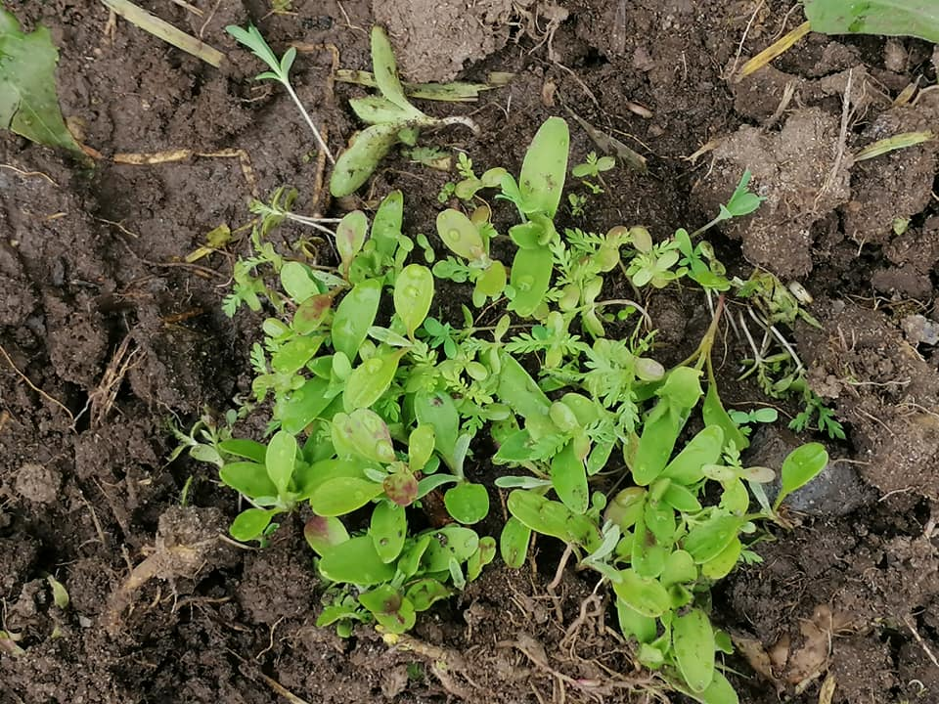
The Cardboard Tray Project loosely based on Charles Dowding’s No Dig methods was designed to give interested people an opportunity to care for and raise wildflower seedlings and proved to be a success. For sure, a great many more wildflower plants have been added to the Meadow. However, the use of a cardboard tray as a substrate was less successful; once the tray became saturated it became difficult to handle. Furthermore, fewer seeds are required. In my enthusiasm I sowed too many too intensively. Fortunately, the plant husbandry was exemplary and the viability of the ‘Projects’ plants is apparent.
The Gatley Carrs Wildflower Meadow has Bird’s-foot Trefoil in abundance, and it stands in testimony to early efforts to create a meadow from scratch. Interestingly Bird’s-foot Trefoil is the favoured food plant for the Six-belted Clearwing moth; a moth disguised as a wasp!
Vampires of the soil
Wildflowers flourish in poor soil and the soil on Gatley Carrs is pleasingly impoverished but dominated by an abundance of grasses that outcompete the flowers for what nutrition there is. Subduing the grasses using herbicide would amount to a form of botanical sacrilege. There are other methods; for example, a group of plants from the broomrape family known as hemiparasites: Yellow Rattle, Corncockle, Common Cow-wheat and Red Bartsia. A hemiparasite is a plant which obtains part of its food by parasitism. The plant sends out long shoots that latch onto the roots of the grasses and drain their nutrients. Yellow Rattle is probably the best known. Research conducted at Little Wittenham Nature Reserve in Oxfordshire discovered that, once it had become established, Yellow Rattle suppressed the grasses and wildflowers flourished in the less competitive environment.
In addition to plug plants, wildflower seed has been sown by hand in two plots on the Meadow. Despite the weather many of the seeds have germinated and seedlings began to appear within four days. The seedlings are now firmly established as nascent plants. Prior to sowing, the seeds were kept in a domestic fridge for two weeks before being mixed with horticultural sand (4 parts sand to 1 part seed) and left in a warm garage for seven days to encourage the first stage of germination.
Note: seed that has thrown its first shoot will prove an unattractive proposition to birds.
Red and white ‘hazard’ tape fixed across the two ‘sown’ plots presented an additional deterrent to the birds.
Interestingly, once tape around the perimeter of the newly sown area was removed the crows walked onto the seeded area. When the perimeter tape was replaced, the crows did not cross. The Wood Pigeons showed no interest whatsoever.
Overall
The restoration Meadow has a long way to go, and I am determined to conquer the grasses. In the dash for cash the countryside has lost 99% of its wildflower meadows. The seeds being sown, the plants being planted are all tiny acts of restitution. Acts of Citizen Conservation which provide habitat for some of the 24 species of bumble bee, 250 species of solitary bee, 59 species of butterfly, 6000 species of hoverfly, 2500 species of moth to name but a few.
Thanks;
Many thanks to Liz, Alan, Alan's patented dibber and Karen who planted a significant number of wildflower seedlings. All of which are flourishing.
In fact, Karen and Alan were planting seedlings they'd grown from seed as part of the 'Cardboard Tray Project'. Good skills!
Les and Stan, following the adage, "thistles cut in May, stay away," weeded the newly sown plot and then started on the meadow itself. Saturday was the first time I'd seen thistles trembling!

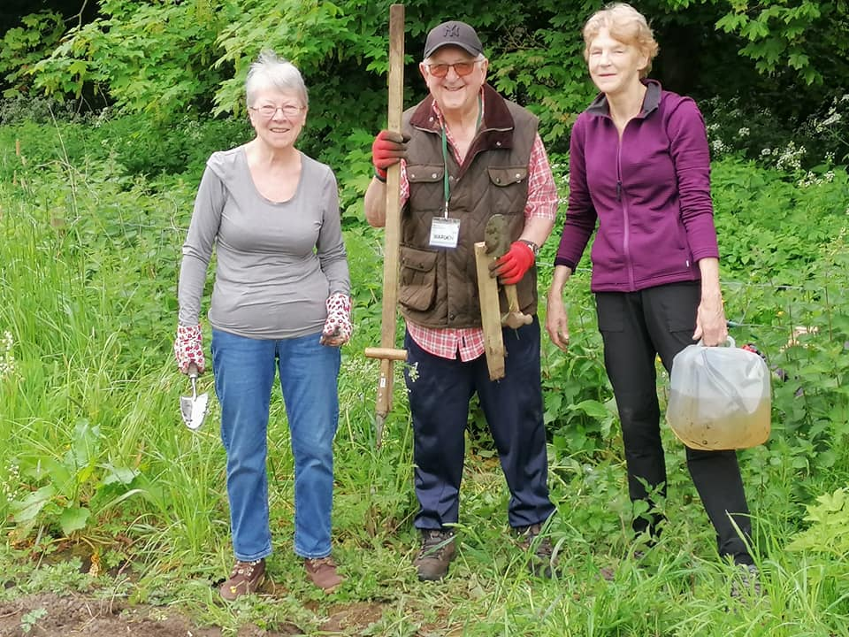

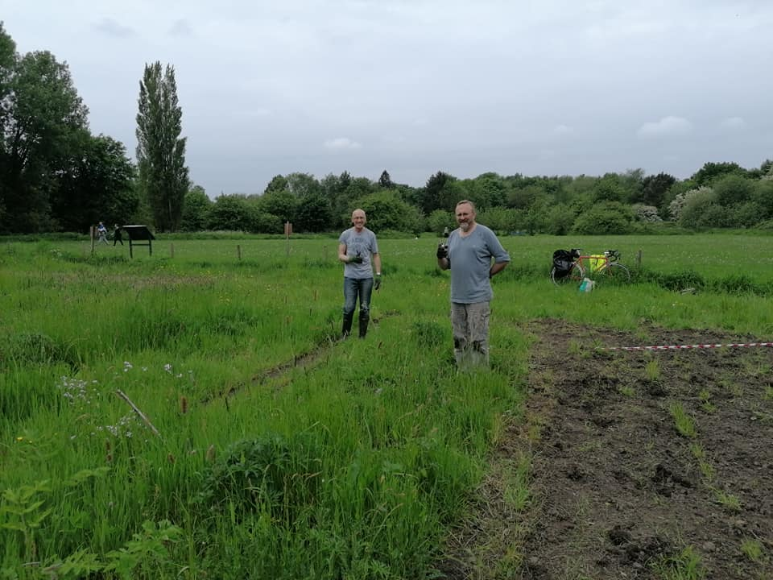

Comment;
Chris is continuing to do an excellent job in overseeing this restoration project and we are very grateful for the back-breaking work he and numerous volunteers have put in to help this along and which will hopefully yield some visible results in this coming year.
Social media report; Emma Burrows
We’ve had a buoyant quarter on our social media Facebook page, with a regular stream of new adds (people joining the page) and lots of people contributing regularly with photos, posts and lots of interest specifically on the pond with the arrival of the gorgeous fluffy goslings in the Spring.
Gary of course makes regular star appearances for our photographers, advanced and novice - he seems to be particularly adept at entertaining his crowd - and it’s lovely for people to all share their experiences of him regularly strutting his stuff and giving so much pleasure to so many.
Conversion rates of new adds on the page into members of the group has been slow this quarter, my intention is to work on this over the summer months and contact the new adds to the page with information and engage with the view of sparking interest and signing them up.
I have been particularly busy since my last report, and I simply have not had the time needed to work on this, I hope to be able to report by September a successful conversion rate into new members gained.
Unfortunately, with the covid restrictions being still quite stringent in March, I was not able to make full use of the social media accounts locally to advertise and push the membership stall and Easter Egg hunt, and the numbers coming through on that occasion shows the significance the media accounts play in gaining footfall.
It was interesting to see how much the social media accounts play such a huge role in getting ourselves out into the local communities and the fact we didn’t specifically promote this activity was demonstrably notable in the far smaller numbers than on previous occasions.
I’m looking forward to keeping the page updated over the summer months with regular updates on the Wild Flower Meadow and of course the diverse natural habitat in its full summer splendour.
I’m calling on all our regular posters to get out there over the next few weeks and fill the page with their photography.
Of all the seasons, the summer months really are a rich and varied abundance of utter joy to capture, and where better to showcase our lovely reserve than on our very own platform to then share across other nature pages both locally and nationally.
Emma Burrows
June 2021.
Comment
Thanks to Emma for taking on this vital role and, as she comments, it is key driver in spreading the word and encouraging members participation both physically and by some great posts on Facebook.
Volunteer work;
We now have a WhatsApp group set up for contacting volunteers and advising when and what tasks need doing. This is now working very well.
If you would like to be added to this group please let me know, message me on 07799 888049 and I will add you into the group.
Any time you can spare all helps enormously
Other happenings on The Carrs;

Please find below a selection of some of the interesting posts from our Facebook page over the last few months, as I know some of you don’t use Facebook I thought you might enjoy seeing them.

Shaun and Freddie Sidebottom

It may be my imagination but I'm sure the buttercups are bigger and better than ever this year

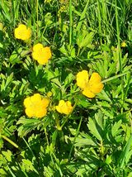

Dave Higginson-Tranter

“Art and abart” with the Carers - a lovely day again - it has gotta be done.

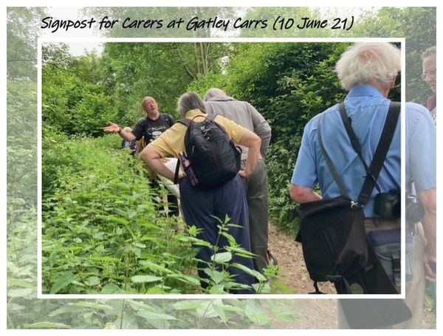

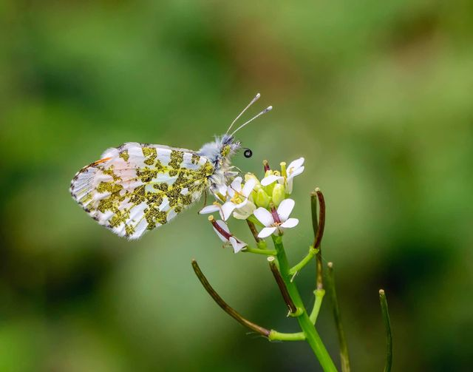

Male Orange Tip Butterfly at Gatley Carrs
Michael Anthony Brathwaite

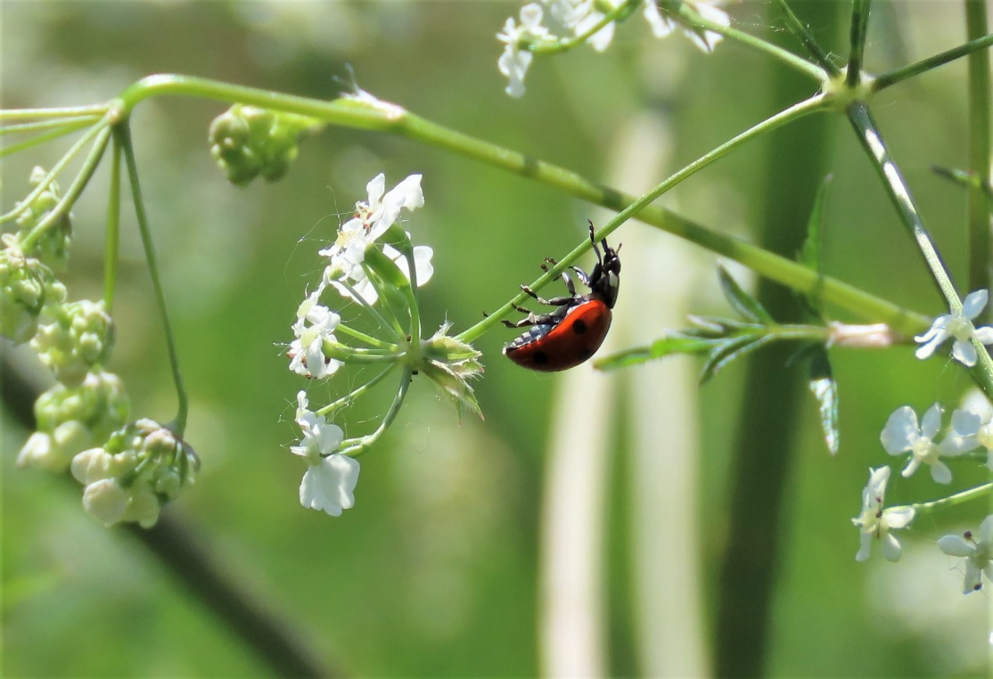

Josie Leibrick

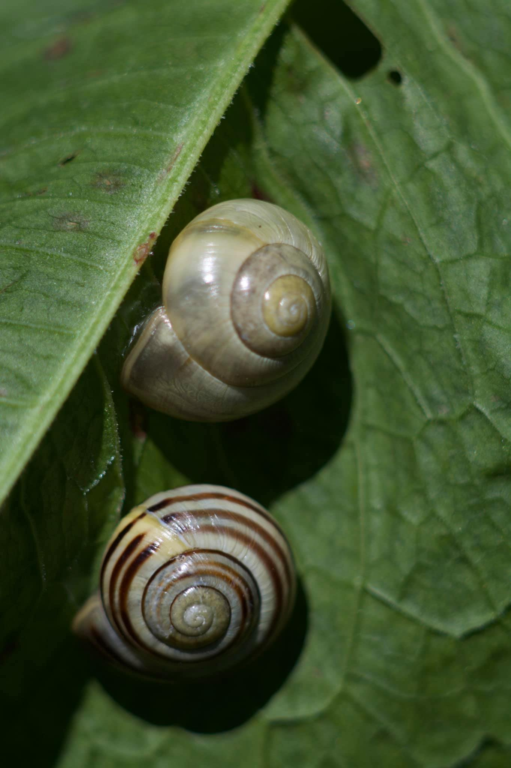
Paul Graham;whirlius snalius ( to give them their latin name)…

Fund raising
We are very grateful to the numerous people who have made donations during the year as they remain vital to our survival.
If anyone is experienced in sourcing funds and support grants we really could do with your help to assist our secretary Pete and myself trying to track these down.
Support from SMBC has increased recently but their funds are severely stretched at the best of times and even worse now due to Covid, so other sources are needed.
Please contact us if you can help.
AOB
Thanks for your continued support.

Peter
Chairman

Next Meeting
Proposed next meeting- 15th September 2021 at 7.30pm

